# Lab -- Chapter 02, Part 01

## Lab Description (lab excerpt, pg 133, #8, Savitch):

The Harris-Benedict equation estimates the number of calories your body needs to maintain your weight if you do no exercise. This is called your basal metabolic rate or BMR.

The calories needed for a woman to maintain her weight is:

BMR = 655 + (4.3 * weight in pounds) + (4.7 * height in inches) – (4.7 * age in years)

The calories needed for a man to maintain his weight is:

BMR = 66 + (6.3 * weight in pounds) + (12.9 * height in inches) – (6.8 * age in years)

A typical chocolate bar will contain 230 calories. Write a program that allows the user to input his or her weight, height, and age. The program should then output both the female and male BMR and the number of chocolate bars that should be consumed to maintain one’s weight for both a female and a male.

## Lab Requirements:

1. The class should be named BMR.java
2. Welcome the user to the program and explain what the program does.
3. Gather input from the user using Scanner or JOptionPane
4. Use Java formatting conventions
5. Use comments where appropriate
6. Use constants where appropriate
   1. For example, the number of calories in a chocolate bar
7. BMR and the number of bars to consume should be a double
8. BMR and the number of bars to consume should be output to the user to only 2 decimal places
9. Your final message’s content should look similar to the message below.
   1. Note, you can output to System.out.println() or JOptionPane (shown below)
   2. 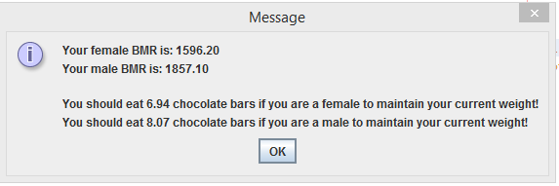
10. Create a short document explaining how you tested your program. This doesn’t need to be anything elaborate. Perhaps just brief discussion of the scenarios you tested and/or a screenshot of a scenario you ran. The idea is that you are starting to test your code.
11. Submit your testing document to Blackboard.
12. Submit your source code to Blackboard
    1. Remember, your submitted source code must compile or a zero will be given